

YEAR 12 PHYSICS

SEMESTER TWO EXAM

2012

Name

Mark

***TIME ALLOWED FOR THIS PAPER***

Reading time before commencing work: Ten minutes

Working time for the paper: Three hours

***MATERIALS REQUIRED/RECOMMENDED FOR THIS PAPER***

**To be provided by the supervisor:**

* This Question/Answer Booklet; Formula and Constants sheet

**To be provided by the candidate:**

* Standard items: pens, pencils, eraser or correction fluid, ruler, highlighter.
* Special items: Calculators satisfying the conditions set by the Curriculum Council for this subject.

***IMPORTANT NOTE TO CANDIDATES***

No other items may be taken into the examination room. It is **your** responsibility to ensure that you do not have any unauthorised notes or other items of a non-personal nature in the examination room. If you have any unauthorised material with you, hand it to the supervisor **before** reading any further.

All calculations are to be set out in detail. Marks may be awarded for correct equations and clear setting out, even if you cannot complete the calculation. Express **numerical answers** to two (2) or three (3) significant figures and include units where appropriate. Express **estimates** to one (1) or two (2) significant figures, and state any assumptions clearly.

**Structure of this paper**

|  |  |  |  |  |  |
| --- | --- | --- | --- | --- | --- |
| Section | Number of questions available | Number of questions to be answered | Suggested working time  (minutes) | Marks available | Percentage of exam |
| Section One:  Short answer | 13 | 13 | 52 | 52 | 29 |
| Section Two:  Extended answer | 8 | 8 | 90 | 90 | 50 |
| Section Three:  Comprehension  and data analysis | 2 | 2 | 38 | 38 | 21 |
|  |  |  | **Total** | 180 | 100 |

**Instructions to candidates**

1. The rules for the conduct of Western Australian external examinations are detailed in the *Year 12 Information Handbook 2012.* Sitting this examination implies that you agree to abide by these rules.

2. Write answers in this Question/Answer Booklet.

3. You must be careful to confine your responses to the specific questions asked and follow any instructions that are specific to a particular question.

1. Working or reasoning should be clearly shown when calculating or estimating answers. It is suggested that answers to calculations are given to 3 significant figures except when you are required to estimate. For estimation questions an appropriate number of significant figures must be stated.

5. Spare pages are included at the end of this booklet. They can be used for planning your responses and/or as additional space if required to continue an answer.

* + Planning: If you use the spare pages for planning, indicate this clearly.
  + Continuing an answer: If you need to use the space to continue an answer, indicate in the original answer space where the answer is continued, i.e. give the page number. Refer to the question(s) where you are continuing your work.

**Section One: Short response 30% (54 Marks)**

This section has **13** questions. Answer **all** questions. Write your answers in the space provided. Suggested working time for this section is 50 minutes.

**Question 1**

Water waves move slower in shallower water than in deep water, which is that cause of surf breakers in W.A. Complete the diagram below to show the accurate shape and pattern of waves coming into shore at an angle as they move from the deep to the shallower water near the beach. Draw in 4 more waves on the diagram below as they move through the shallow water.

Shallow

Deep

(3)

**Question 2**

When demonstrating the photoelectric effect a beam of light is shone onto a clean metal surface. The light may be able to cause electrons to be ejected from the surface. Consider the graph below of data collected from a photoelectric cell.

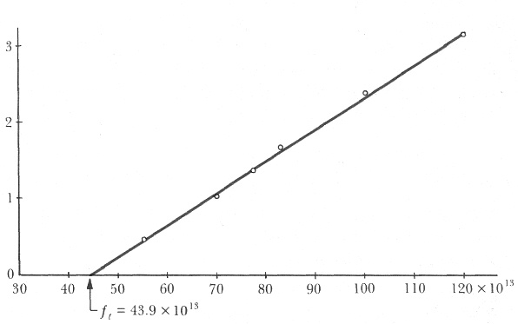

1. Explain is the significance of the intercept on the x axis

(2)

1. On the axes in another colour sketch the graph that would be collected if the type of metal in the clean surface is replaced with one of a higher ionization energy.

(2)

**Question 3**

77.2°

7.30 kg hammer

1.21 m

A student is investigating the physics of the hammer throw event at the London Olympics. A hammer of mass 7.30 kg is describing uniform circular motion at a constant height. The length of the hammer is 1.21 m and the wire makes an angle of 77.2° with the vertical. Calculate the time taken for the hammer to make one revolution.

(5)

**Question 4**

A jet is flying directly over the magnetic pole in the Northern geographical hemisphere. The jet is flying at 858 km h-1, it has a wingspan of 15.0 m and the Earth’s magnetic flux density at this location is 57.8 μT.

Magnetic Pole Northern Hemisphere

Jet (flying out of page)

1. On the diagram show the Earth’s magnetic field at this location by using 5 lines.

(1)

(b) Indicate on the diagram where electrons will build up on the wingspan.

(1)

(c) Calculate the emf induced across the wingspan.

(2)

**Question 5**

A spacecraft moving at 95% of the speed of light passes the Earth on a journey to the star Lalande 21185 a distance of 8.29 light years.

1. In the frame of reference of the spacecraft what time and spatial measurements of the journey are different compared to those measured by an Earth based observer?

(3)

1. Is it possible for the spacecraft to travel at the speed of light in the frame of reference of the spacecraft? Explain briefly.

(1)

|  |  |
| --- | --- |
| **Quark** | **Charge** |
| Up (u) |  |
| Down (d) |  |
| Charmed (c) |  |
| Strange (s) |  |
| Top (t) |  |
| Bottom (b) |  |

**Question 6**

There are six flavours of quarks (normal matter versions).

These are detailed in the table.

1. Determine the charge of the following particles that are made from quarks:

Bottom Xi prime _________



Kaon-plus _______



(2)

1. Give an example from your studies of when a neutrino could come into existence.

(2)

**Question 7**

Oxygen ions (O2-) are injected into a vacuum chamber that contains a uniform magnetic field. For the cross section shown the magnetic flux is 2.88 🞩 10-4 Wb in an area 30.0 cm by 20.0 cm. The direction of the magnetic field is indicated and the ions enter at a speed of 2.76 🞩 104 m s-1.

⦁ ⦁ ⦁ ⦁ ⦁

⦁ ⦁ ⦁ ⦁ ⦁

⦁ ⦁ ⦁ ⦁ ⦁

O2- ions enter moving left

Vacuum chamber

a) In which direction will the ions be deflected? (Circle the correct response)

up the page down the page into the page out of the page

(1)

b) Calculate the magnitude of force experienced by each ion. (3)

**Question 8**

Bowling ball

Pivot

Plank

Rope

A rigid wooden plank of mass 2.5 kg is attached to a wall by a pivot and is supported by a rope in tension. A 3.5 kg bowling ball is suspended from the plank. The diagram is to scale. **Estimate** the tension in the rope. Express your answer to an appropriate number of significant figures.

(4)

**Question 9**

A rigid boom of mass m is free to rotate about a frictionless pivot P. The boom is held in static equilibrium by a rope that is in tension. The boom is held in two different positions where the tension in position A is TA and the tension in position B is TB. The positions are shown in the diagram below.

Position A

Position B

TA

TB

**P**

**P**

Boom

Boom

60°

90°

1. When comparing the magnitude of tension in each position, circle the best response:

(1)

TA  = TB TA  > TB TA  < TB Insufficient information for a response

1. Clearly explain your choice.

(3)

**Question 10**



In the WACE Physics course we assume that the flux linkage between the primary and secondary windings of a transformer is always 100% efficient. However we recognise that the transformer itself may not be 100% efficient.

1. Describe two sources of inefficiency in a transformer.

(2)

1. Describe how each of these effect the transformer output

(2)

i)

ii)

**Question 11**

(4)

**N S**

⦿

1. The diagram at right shows a permanent magnet and a wire carrying current.
2. Sketch 6 lines to indicate the field of the magnet.
3. Indicate on the diagram the direction of magnetic force acting on the wire
4. The diagram at right shows the cross section of a powered solenoid. The magnetic polarity at each end of the solenoid is shown.

**N**

**S**

1. Show on the diagram, the direction of current that will establish this field.
2. Sketch 3 magnetic field lines within the solenoid core.

**Question 12**

Arc of swing

A person is sitting on a swing that is moving through the arc of a circle. It has reached the lowest point and is moving at maximum speed. Explain with reference to a vector diagram how the person’s apparent weight is different compared to being at rest on the swing.

(4)

**Question 13**

The Steady State Theory (also called The Infinite Universe Theory) was a model developed by the respected astronomer Fred Hoyle and others in 1948. It proposed that the universe had no beginning or end over infinite time. Fred Hoyle is reported to have used the phrase ‘Big Bang’ as a derogatory term when referring to an alternative theory that is nowadays the most widely accepted.

Describe two pieces of observational evidence that support the Big Bang Theory.

(4)

**End of Section One**

**Section Two: Problem-solving 50% (90 Marks)**

This section has **eight (8)** questions. You must answer **all** questions. Write your answers in the space provided. Suggested working time for this section is 90 minutes.

**Question 14 (13 marks)**

The diagram shows the side view of a DC electric motor. A square coil is placed flat in the uniform magnetic field between the North and South magnetic poles. Current direction in this starting position is into side A of the coil. The commutator and carbon brushes are also shown.

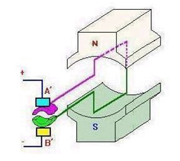

1. As viewed from the front of the picture, In which direction will the coil rotate from this start position? Explain.

(2)

(b)Explain the function of the brush and commutator arrangement.

(2)

1. The torque produced in the diagram above has a magnitude of 1.00 Nm. After 60º of rotation from the start position; state the torque value of the motor.

(3)

1. The motor is later modified to have three evenly spaced coils and a commutator with 6 segments. On the axes below the individual torque output for each coil has been graphed and the total torque has also been graphed. Explain the shape in the graph for torque for any one of the individual coils.

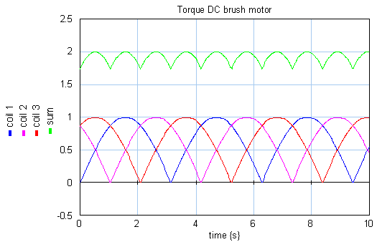

(2)

(e)Explain the torque values for the total torque produced by the 3 coil system.

(2)

(f)Give one reason why the three coil system would be more appropriate for a motor in a movie projector

(2)

**Question 15 (13 marks)**

A recording studio builds a simple wind instrument closed at one end. The effective length of the instrument is 135 cm and is fixed.

Microphone on end of rod within the air column

Open end of instrument

Closed end

Mouthpiece

1. If the instrument has a fundamental frequency of 64.0 Hz, calculate the speed of sound of air in the studio.

(3)

1. Explain how a musician can play notes of a higher frequency on this fixed length instrument.

(2)

1. The musician is unable to produce a sound of frequency 128 Hz on this instrument. Explain why this is not possible.

(2)

When the instrument is playing a note of frequency 320 Hz, a sound technician slides a small microphone into the tube without disrupting the sound. As he does, he notices the sound volume varies between loud and soft.

(d) Explain why there are loud and soft spots within the instrument.

(2)

For a given note played on a musical instrument, the dominant frequency heard is called the fundamental frequency or the first harmonic. Harmonic frequencies above the fundamental frequency, that are present, are known as overtones. Harmonics above the fundamental frequency are known as the first overtone, the second overtone etc.

(e) The studio has a simple stringed instrument in which a steel string in tension can oscillate between two fixed bridges. On the diagram below sketch the wave envelope of the second overtone.

(1)

Bridge

Bridge

(f) When the wind instrument is sounding a note of 64.0 Hz, sound waves travel through a small gap in a partially open window to the outside where reflections are negligible. A microphone placed to the side of the gap can still detect these sound waves. This is shown in the following diagram.

Didgeridoo

Outside

Wavefronts 🡪

Gap

Microphone

1. Explain the wave phenomenon that causes the sound from the wind instrument to be detected by the microphone.

(2)

1. Show on the diagram how wavefronts from the stringed instrument sounding at 320 Hz will reach the window and continue through the air gap. You must show relative wavefront dimensions approximately to scale originating from the same location as the didgeridoo.

(1)

**Question 16 (12 marks)**

A physics student observes a stone of mass 350 g being catapulted from the top of a cliff. The launch position at the top of the cliff is 15.0 m above ground level and it takes the stone a time of 5.00 seconds to reach the ground. The stone lands 88.0 m in front of the launch position. You may ignore air resistance for the calculations.

15.0 m

88.0 m

Cliff

1. Calculate the vertical component of the velocity when the stone is launched.

(3)

1. Considering the kinetic energy of the stone along its flight path. Circle the best response for the following statement. The kinetic energy of the stone at maximum height is:

Maximum 50% of maximum Zero Minimum Equal to all other positions

(1)

1. Calculate the initial velocity of the stone, referring to the angle of elevation above the horizontal for direction.

(4)

1. Calculate the kinetic energy of the 350 g stone just before it hits the ground.

(4)

**Question 17 (13 marks)**

The diagram shows the coil PQRS of an AC generator placed between magnetic poles.

* The uniform magnetic field of flux density 0.0386 T is indicated.
* The dimensions of the coil are: PQ = SR = 7.00 cm and PS = QR = 5.00 cm
* The coil is rotated about the axle as indicated when a torque is applied to the pulley.
* The coil has 400 turns of wire and is rotated at 750 revolutions per minute (rpm).

A

Contacts to external circuit

Pulley that turns coil

Axle

🞫 🞫 🞫 🞫 🞫 🞫

🞫 🞫 🞫 🞫 🞫 🞫

🞫 🞫 🞫 🞫 🞫 🞫

🞫 🞫 🞫 🞫 🞫 🞫

**P**

**R**

**Q**

**S**

**PQ rotates out of page**

**SR rotates into page**

B

1. Identify component A shown on the diagram, and explain why its polarity changes as the coil is rotated in the field. (3)
2. Mark on the diagram the direction of current along PQ and SR as the coil rotates at the position shown and explain briefly how you arrived at your answer.

(2)

1. Calculate the magnitude of the average induced emf from this AC generator by considering one quarter of a rotation from the position shown.

(4)

1. On the axes shown below, sketch the shape of the emf output for this generator as it rotates one full turn from the initial position shown. Put in a suitable numerical time scale on the time axis and label your curve ‘750 rpm’.

(2)



1. Sketch a second shape of the emf output for a rate of rotation of 1500 rpm and label this curve ‘1500 rpm’.

(2)

**Question 18 (13 marks)**

The energy level diagram below is for an atom that can fluoresce.

Ground state E1

E2

E3

E4

E5

E∞

-12.70 eV

-7.52 eV

______ eV

-4.27 eV

-3.18 eV

zero eV

1. The atom is bombarded by 4 photons with energies detailed below. Circle all of the photon energies that could be absorbed by the atom whilst in its ground state.

(1)

5.08 eV 5.18 eV 8.43 eV 13.0 eV

1. Whilst in the ground state the atom absorbs a photon of wavelength 171.23 nm which excites the atomic electron to E3. Calculate the energy level of E3 and write it in the box on the diagram and also illustrate the transition on the diagram. Label the transition ‘171.23 nm’.

(4)

1. Which part of the electromagnetic spectrum does the 171.23 nm photon belong to?

(1)

1. For the energy levels shown on the diagram below which transition will result in line emission of the longest wavelength? Illustrate this transition on the diagram and label it **‘λmax’**

(1)

1. Explain how a line absorption spectrum could be formed by a collection of these atoms.

(3)

1. Explain the process of fluorescence. You may use the energy level diagram below to aid your response.

Ground state E1

E2

E3

E4

E5

E∞

-12.70 eV

-7.52 eV

-4.27 eV

-3.18 eV

zero eV

(3)

**Question 19 (13 marks)**

The orbit of Venus lies between the Earth’s orbit and the Sun. The radius of Venus is 6.05 🞩106 m. The Magellan spacecraft was launched by NASA in 1995 for the purpose of radar mapping Venus. At one stage Magellan was put into a circular orbit of Venus at an altitude of 346 km. It took Magellan 94 minutes to complete this orbit. Magellan had a mass of 1035 kg.

1. Calculate the centripetal acceleration of the Magellan satellite in this orbit.

(3)

1. Calculate the mass of the planet Venus using the satellite data provided.

(3)

1. If the Magellan spacecraft was double the mass in this orbit explain how its orbital period would be affected.

(2)

1. There is a location between the Earth and the Sun where the net gravitational field strength due to the Earth and the Sun is zero. Calculate the distance from Earth to this location.

(5)

**Question 20 (7 marks)**

A stream of single positive ions is fired at right angles into two force fields arranged as depicted below. The parallel plates are 5.00mm apart.

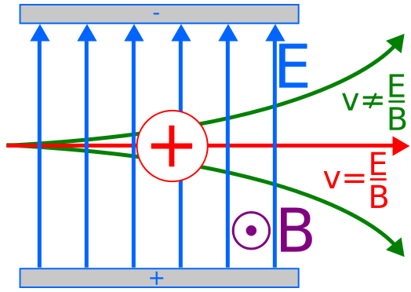

The magnetic field is uniform and of field intensity B equal to 0.300T. It is directed vertically out of the page.

1. Explain why some ions go straight through the combined field without deflection.

(2)

1. Why do some of the ions swing upwards as they cross the combined fields.

(2)

1. Calculate the velocity of the ions if they are **undeflectd** when the potential difference between the parallel plates is set at 605 V .

(3)

**Question 21 (6 marks)**

NGC 2768 is a galaxy group that can be observed from the Hubble Space telescope. The line absorption spectrum of light passing through a metallic vapour in this galaxy shows one line with a wavelength of 742.540 nm. The same line in the spectrum measured on Earth is 740.400 nm.

1. Calculate the recessional velocity of NGC 2768 using the following relationship:

(2)

  where and v = recessional velocity (m s-1)

Δλ = λshifted  - λrest

1. Using Hubble’s law, calculate the distance in Mpc to galaxy NGC 2768 using the velocity you calculated. *(If you could not solve for the velocity then use a value of 8.67 × 105 m s-1)*

(2)

Hubble’s law states that: v = H0. d v = recessional velocity (km s-1)

d = distance (Mpc)

H0 = 74.0 km s-1 Mpc-1

1. How many years has it taken light from this galaxy to reach Earth? (1 parsec = 3.26 light year)

(2)

**End of Section 2**

**Section Three: Comprehension 20% (36 Marks)**

This section contains **two (2)** questions. You must answer both questions. Write your answers in the space provided. Suggested working time for this section is 40 minutes.

**Question 22 Using a mass spectrometer for a crime scene investigation. (18 marks)**

Australian Federal Police have isolated an element found at a crime scene. They think the element may be sodium or potassium so have asked the forensic laboratory to run tests on the element to identify it. The laboratory is able to ionise the element to give it a single positive charge. They then accelerate the ions through a potential difference (Vd) and by use of a velocity filter are able to send ions that have reached their maximum kinetic energy into a mass spectrometer. When the ions enter the mass spectrometer they are acted on by a uniform magnetic field and follow a semi -circular path.

Technicians conduct a series of tests and measure the radius of circular motion for different values of potential difference used to accelerate the charged ions.

*Schematic diagram of mass spectrometer*

Positive ion beam follows semicircular paths

Magnetic flux density B within chamber fixed at 3.50 🞩 10-2 T

Ionisation

Accelerating Voltage

*Adjustable Vd*

Faraday plates detect ion strikes

Velocity filter

The table below shows the results obtained when the magnetic flux density B in the mass spectrometer was fixed at 3.50 🞩 10-2 T. Measurements of radius have been expressed with an uncertainty of ±5% and radius squared with an uncertainty ±10%.

|  |  |  |
| --- | --- | --- |
| Potential difference Vd  (volts) | Radius of circular path (metres) | Radius squared  (metres squared) |
| 200 | 0.270 ± 0.014 | 0.073 ± 0.007 |
| 400 | 0.370 ± 0.019 |  |
| 600 | 0.490 ± 0.025 |  |
| 800 | 0.530 ± 0.053 |  |
| 1000 | 0.620 ± 0.027 |  |
| 1200 | 0.670 ± 0.034 | 0.449 ± 0.045 |

Mass of a potassium K+ ion = 6.49 × 10-26 kg Mass of sodium Na+ ion = 3.82 × 10-26 kg

It can be shown that the radius ***r*** of circular motion for an ion of mass ***m*** and charge ***q***, entering the mass spectrometer at speed ***v*** and being deflected by a magnetic field of flux density ***B*** is as follows:



Answer the following questions

1. Use the equation and other equations on the formulae and constant sheet that link the kinetic energy in (joules) attained by a mass of charge **q** (coulombs) in a potential difference **Vd** (volts) and derive the following expression:



(3)



The equation follows the format **y = mx + c** for values of r2 plotted against Vd

1. Complete the table by filling in the values of radius squared **r2** with the appropriate uncertainty range. Two values have been done for you.

(3)

1. Plot the graph of **r2** (vertical axis) versus **Potential difference Vd** (horizontal axis) on the graph paper next to the table. Include error bars and a line of best fit.

(5)

If you need to make a second attempt, spare graph paper is at the end of this question. Indicate clearly if you have used the second graph and cancel the working on the first graph.



1. Calculate the gradient of your line of best fit from your graph showing all working.

(3)

1. Use the value of the gradient that you obtained to calculate the mass of the charged ions. (If you could not obtain a gradient use the numerical value 4.00 × 10-4)

(3)

1. Based on the results you have calculated, what is the identity of the charged ion?

(1)

2. **The Earth's Magnetic Field**

The Earth has a substantial magnetic field, a fact of some historical importance because of the role of the magnetic compass in exploration of the planet.

**Structure of the Field**

The field lines defining the structure of the magnetic field are similar to those of a simple bar magnet, as illustrated in the following figure.

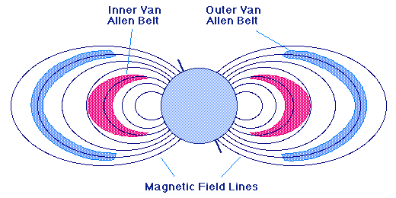

**Inner Van Allen Belt**

**Outer Van Allen Belt**

**Magnetic Field Lines**

Figure 1: The Earth's magnetic field and Van Allen radiation belts

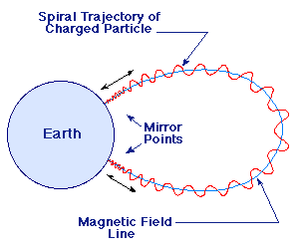

**Spiral Trajectory of   
 Charged Particles**

**Magnetic Field Line**

**Mirror Points**

It is well known that the axis of the magnetic field is tipped with respect to the rotation axis of the Earth. Thus, true north (defined by the direction to the north rotational pole) does not coincide with magnetic north (defined by the direction to the north magnetic pole) and compass directions must be corrected by fixed amounts at given points on the surface of the Earth to yield true directions.

**Van Allen Radiation Belts**

A fundamental property of magnetic fields is that they exert forces on moving electrical charges. Thus, a magnetic field can trap charged particles such as electrons and protons as they are forced to execute a spiralling motion back and forth along the field lines. As illustrated in the figure above, the charged particles are reflected at "mirror points" where the field lines come close together and the spirals tighten. One of the first fruits of early space exploration was the discovery in the late 1950s that the Earth is surrounded by two regions of particularly high concentration of charged particles called the Van Allen radiation belts.

The inner and outer Van Allen belts are illustrated in the top figure. The primary source of these charged particles is the stream of particles emanating from the Sun that we call the solar wind. As we shall see in a subsequent section, the charged particles trapped in the Earth's magnetic field are responsible for the aurora (Northern and Southern Lights).

**Origin of the Magnetic Field**

Magnetic fields are produced by the motion of electrical charges. For example, the magnetic field of a bar magnet results from the motion of negatively charged electrons in the magnet. The origin of the Earth's magnetic field is not completely understood, but is thought to be associated with electrical currents produced by the coupling of convective effects and rotation in the spinning liquid metallic outer core of iron and nickel. This mechanism is termed the dynamo effect. Rocks that are formed from the molten state contain indicators of the magnetic field at the time of their solidification. The study of such "magnetic fossils" indicates that the Earth's magnetic field reverses itself every million years or so (the north and south magnetic poles switch). This is but one detail of the magnetic field that is not well understood.

**The Earth's Magnetosphere**

The solar wind mentioned above is a stream of ionized gases that blows outward from the Sun at about 400 km/second and that varies in intensity with the amount of surface activity on the Sun. The Earth's magnetic field shields it from much of the solar wind. When the solar wind encounters Earth's magnetic field it is deflected like water around the bow of a ship, as illustrated in the image above. ('http://www-spof.gsfc.nasa.gov/Education/Figures/stsys.gif','magnetic',755,335).

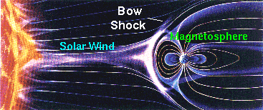

The imaginary surface at which the solar wind is first deflected is called the bow shock. The corresponding region of space sitting behind the bow shock and surrounding the Earth is termed the magnetosphere; it represents a region of space dominated by the Earth's magnetic field in the sense that it largely prevents the solar wind from entering. However, some high-energy charged particles from the solar wind leak into the magnetosphere and are the source of the charged particles trapped in the Van Allen belts.

Questions:

a. What is the difference between True North and Magnetic North.

(2)

b. How does the Earth’s magnetic field *trap* charged particles from the Sun to form the Van Allen Belts?

(2)

c. The Aurora (paragraph 3) can be seen from Southern regions such as New Zealand. Briefly explain the Physics behind this phenomenon. Be sure to include how the light is actually produced.

(6)

d. How is the magnetic field of a bar magnet generated?

(2)

e. What evidence is there that the magnetic poles of the Earth have *switched* every few million years?

(2)

f. The Earth’s magnetic field shields the Earth from solar wind. If the Earths axis was rotated 90° so that the South Pole faced towards the Sun, would this influence the effectiveness of the shielding effect? Explain.

(3)

g. An alpha particle streaming from the Sun at 400.0 km s-1 is deflected by the Earths Magnetic Field, so that its radius of curvature is 2.00 x 108 m. If the alpha particle has a mass of 6.65 x 10-27 kg and a charge of 6.40 x 10-19 C, find the intensity of the Earth’s magnetic field at that point.

(3)

**END OF SECTION C**